Entry Customer Forum
MINUTES
Tuesday 30 May 2023 at 12.30PM – 2.00PM
MS Teams
ATTENDEES
Name | Initials | Company
Wasundara Doradeniya | WD | ADBA
Tom Knight | TK | Bohr Energy
Tina Hawke | TH | Cadent
John Baldwin | JB | CNG Services
James Earl | JE | ENA
Katie Harrison | KH | ENA
Matt Rosenfeld | MR | ENA
Nick Primmer | NP | Future Biogas
Ian McCluskey | IMC | IGEM
Emma Buckton | EB | NGN
Nick Smith | NS | NGN
Russell Brown | RB | nZERO
Paul Worthington | PW | Orbital
Elysia Roy | ER | SGN
Joel Martin (Chair) | JM | SGN
Andy Bidston | AB | Thyson
Charlotte Marcel | CM | WAGA
Bethan Winter | BW | WWU
MEETING NOTES AND ACTIONS
2. Action Log Update | MR
The group’s action log was updated.
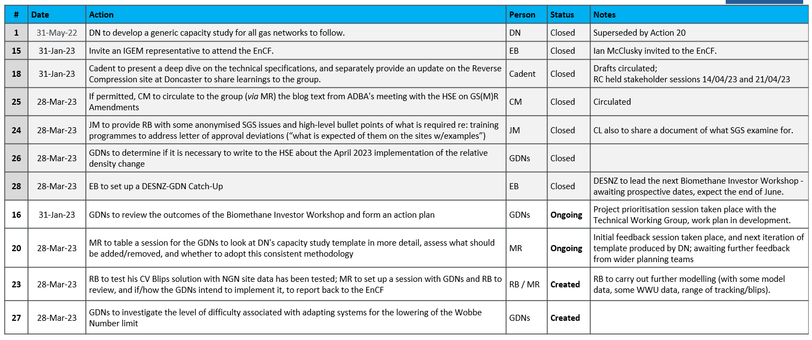
On Action 27 – JB suggested a phased change in a timely fashion where possible to adapt systems for the lowering of the Wobbe limit (if change was needed at all, since the limit was never approached). RB updated that, on one site, they had already removed the SI and ICF trip on the DFO side (technically widening the limit and removing the alarm on the GDN side), and added an RD trip on the DFO side.
From a software perspective, the change for Wobbe would be fairly easy to implement, and might not require an end-to-end test; the harder job would be assessing the impacts based on feedstocks etc.

3. EnCF Action Plan Tracker | JM
1. CV Blips (RB)
RB had initially been using real site data to test his CV blips model, but this was proving troublesome to analyse without knowing the target CV, and without being able to tell if variations were caused by CV blips (without going into details of the alarms). Instead, RB was now using two model datasets, one steadier and one more inconsistent (but within range), and introducing various blips throughout the day. The modelling was complete and being written up into a more palatable presentation.
As per Action 20, the next steps were for RB to circulate the modelling spreadsheet and PowerPoint for the GDNs to examine, and to hold a session to discuss the results and implementation in further detail.

2. Biomethane Blending (TH)
Cadent’s biomethane blending strategy was out for review with internal stakeholders, and going to final signoff by the end of June for circulation among the GDNs and then to EnCF.

3. SGS Issues (JM)
The updated SGS Issues dashboard was shared with the group (below), noting that the Q1 figures were comparable with previous years’ yearly figures. Anonymised examples and a standardised guidance document/letter of direction were due to be circulated to assist producers with these issues. GDNs were also continuing to interrogate the data for common problems leading to these SGS Issues, e.g., recent problems with availability of test gas.

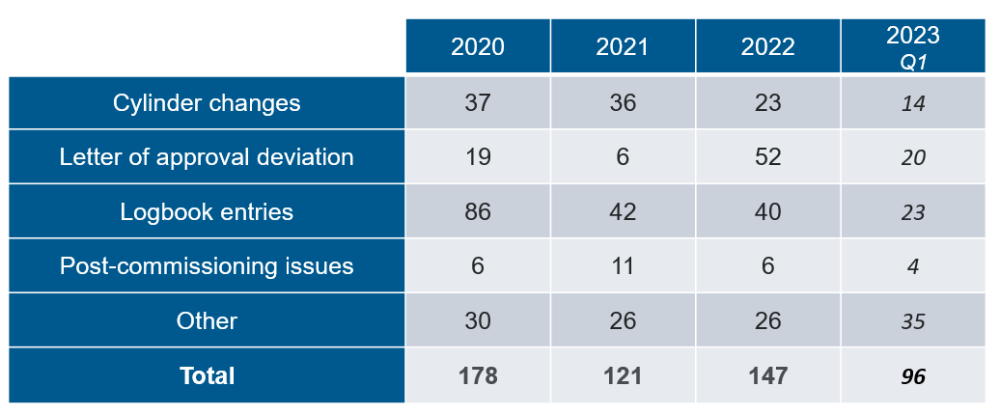

4. Standardisation of ME2 (n/a)
ACTION: BH to provide a post-meeting update.

5. Operator Competence Accreditation (TH)
TH was looking to progress this action through AM.

6. Standardisation of Capacity Studies (MR for DN)
DN’s capacity study template had gone through one iteration with the network planning teams and was currently out for further review. Pending completion of feedback, and review by the Technical Working Group, the template would be shared with the EnCF.
JB reiterated the desire to include discussion on pressure control / reverse compression as part of the “next steps” in the capacity studies. TH and JM confirmed that this was feeding into the new template.
AB suggested including the volume throughput on the mainline, as this would be handy for insight into blending availability (i.e., do you have enough gas to blend in?); as per the blending strategy, this was the first stage in facilitating blending (but note that blending will not always be possible).
ACTION: MR to pass discussed capacity study feedback onto DN, for discussion at the Technical Working Group.

7. In-Grid Compression (JB for AC)
The next steps were for the technical specifications to go to through the Technical Standards Forum, the GDN’s standards review group.
Additionally, JB relayed his experience visiting a GRTF compressor site in France (the first of fifty aiming to be online by 2035) relating to a specific project in Ireland. Fifteen smaller-scale AD sites fed into a 10 bar grid (still fairly substantial, c.5000m³h⁻¹, with compression from 8.5 bar to 7.5 bar). The ownership model differed from the UK, in that GRTF own both the distribution and transmission networks; they have their own staff, own the site, and a standard compressor was provided by the manufacturer.
ACTION: JB to circulate notes and photographs from GTRF compressor site visit; all open to express interest in a further visit to a compressor site in Denmark.
ACTION: TH to share Cadent’s tool for outlining in-grid compression scope to the GDNs, Ruth Burden to set up a session going through the tool.
ACTION: TH to share the (NIA) OptiNet Closeout Report with the group once published.

8. Low Flow through NTS Meters (JB for AC)
JB was still awaiting a reply from Steve Brown (Ofgem) to his letter on NTS Exit Metering. JB opined that, barring odorant control, NTS Exit Metering was no longer necessary, since no gas was leaving the system, and could be replaced with, e.g., AI. BW and JM noted that this would create issues with Xoserve, as all their settlements were based on the NTS Exit inputs (since they were the most accurate and subject to the most robust checking), so this would be a fundamental change to the central systems.

9. Gas Entry via IGT Pipelines (JM)
The UNC Mod had been proposed and was still under discussion by the relevant working group.

4a. Biomethane Innovation | JB
JB noted that the ENA Energy Innovation Programme (“Basecamp”) had focused primarily on the transitions to hydrogen and electrification, and pushed for biomethane to feature more heavily in the next iteration of the event. TH expressed the same sentiment on behalf of the networks’ biomethane teams.
JE and MR reiterated that, ordinarily, innovation ideas are welcomed outside of this process both via the Smarter Networks Portal and directly to the networks’ innovation mailboxes, and the key takeaway for now was to ensure that ideas raised in the EnCF could progress to network innovation colleagues. Logistical and communications problems arising from the Energy Innovation Programme were to be ironed out.

4b. Commercial Propane | RB / JB
RB was in the process of finishing a technical report on the effects of contamination found within commercial propane; sites were having to clean meters and assets much more often, with some seeing blockages and flow restrictions in pipework, and staff could potentially be facing greater exposure to carcinogens present in the oily sludge e.g., toluene. Similar issues were being seen in other industries, e.g., in forklift trucks and caravans. The main issue seemed to be polymerisation (>10%) due to increased presence of propene, without much dependence on the way propane was added (e.g., vaporisation vs. liquid injection, proximity to the meter…).
The group was also in agreement that even though the issue was widespread, there were variations based on the origins of the propane (propane from Scottish sites historically had been of higher quality).
The major propane suppliers (Flogas and Calor) had been approached separately by a number of sites, but the usual response was that the gas quality was compliant with the British Standards. IMC offered to pick this up with the Gas Utilisation Committee, on which Liquid Gas UK sat.
RB suggested also that interim R&D solutions to treat the propane (e.g., as a liquid, using activated charcoal) before injection may be another viable route to explore.
ACTION: RB to send IMC a copy of his technical report on propane contamination, and brief IMC to raise the issue at the Gas Utilisation Committee.
ACTION: RB to brief TH on his report on propane contamination, for TH to follow up with ADBA.
ACTION: GDNs to consider other actions re: lobbying for better quality commercial propane.

